# 1. WAP to display Hello World

#include<iostream>  
using namespace std;  
int main()  
{  
 cout<<"Hello World"<<endl;  
 return 0;  
}

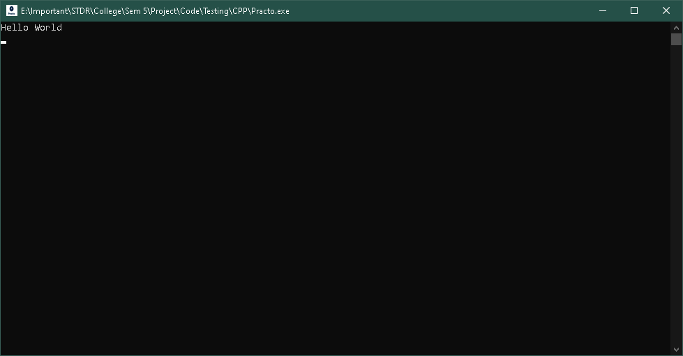

# 2. WAP Take Name as Input and Great the user

#include<iostream>  
using namespace std;  
int main()  
{  
 string name;  
 cout<<"Enter your Name: ";  
 cin>>name;  
 cout<<"Hello "<<name<<endl;  
  
 return 0;  
}

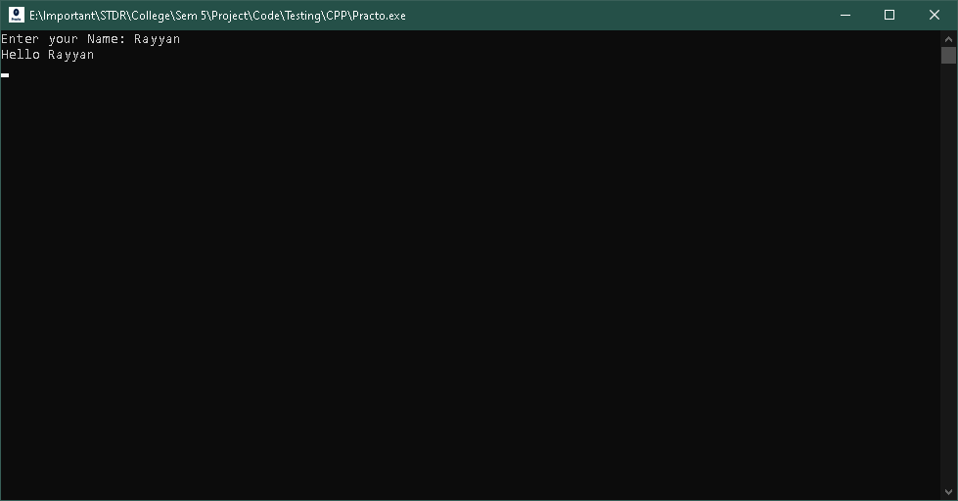

# 3. WAP to display the table of a given Number

#include<iostream>  
using namespace std;  
int main()  
{  
 int n;  
 cout<<"Enter a number to display table"<<endl;  
 cin>>n;  
 for (int i = 1; i <= 10; i++)  
 {  
 cout<<n<<" x "<<i<<"="<<n*i<<endl;  
 }  
   
 return 0;  
}

